

­­­

OOP Lab-07 Tasks

Name: Syed Muhammad Raza Ali

Enrolment: 02-134231-028

Course: OOP Lab

Faculty: Miss Hafsa Munawar

In this lab, the following topics will be covered:

1. **Inheritacen (in Java)**
2. **Exercise for practice**

Exercises

Exercise 1

The UML diagram of a Bank Account system that contains the following classes.Write Java code for these classes.

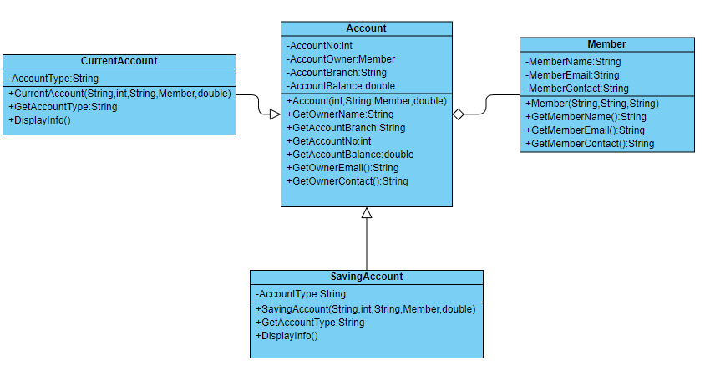

Imlement all classes given in UML diagram.

Create Driver class named as **Inheritance_2**. Create proper Objects of all classes as follows

* Create three objects of **Member** class. Two of which have **current account** and one has **saving account.** Properly display all the information.

# Code:

package com.mycompany.mavenproject4;

class Account{

private int accountNo;

private Member accountOwner;

private String accountBranch;

private double accountBalance;

//methods

public String getOwnerEmail(){

return accountOwner.getMemberEmail();

}

public String getOwnerContact(){

return accountOwner.getMemberContact();

}

//getters

public int getAccountNo() {

return accountNo;

}

public String getAccountBranch() {

return accountBranch;

}

public double getAccountBalance() {

return accountBalance;

}

//constructors

public Account(int accountNo, Member accountOwner, String accountBranch, double accountBalance) {

this.accountNo = accountNo;

this.accountOwner = accountOwner;

this.accountBranch = accountBranch;

this.accountBalance = accountBalance;

}

public Account() {

}

@Override

public String toString() {

return "Account{" + "accountNo=" + accountNo +

", accountOwnerName =" + accountOwner.getMemberName() + ", accountBranch=" +"AccountOwner Email : "+accountOwner.getMemberEmail()+

"Account Branch : "+accountBranch + ", accountBalance=" + accountBalance + '}';

}

}

class Member{

private String memberName,memberEmail,memberContact;

//getters

public String getMemberName() {

return memberName;

}

public String getMemberEmail() {

return memberEmail;

}

public String getMemberContact() {

return memberContact;

}

//constructors

public Member(String memberName, String memberEmail, String memberContact) {

this.memberName = memberName;

this.memberEmail = memberEmail;

this.memberContact = memberContact;

}

public Member() {

}

}

class CurrentAccount extends Account{

private String accountType;

public String getAccountType() {

return accountType;

}

public CurrentAccount(String accountType) {

this.accountType = accountType;

}

public CurrentAccount() {

}

public CurrentAccount(String accountType, int accountNo, Member accountOwner, String accountBranch, double accountBalance) {

super(accountNo, accountOwner, accountBranch, accountBalance);

this.accountType = accountType;

}

@Override

public String toString() {

return super.toString()+"currentAccount{" + "accountType=" + accountType + '}';

}

}

class SavingAccount extends Account{

private String accountType;

public SavingAccount() {

}

public SavingAccount(String accountType, int accountNo, Member accountOwner, String accountBranch, double accountBalance) {

super(accountNo, accountOwner, accountBranch, accountBalance);

this.accountType = accountType;

}

public SavingAccount(String accountType) {

this.accountType = accountType;

}

public String getAccountType() {

return accountType;

}

@Override

public String toString() {

return super.toString()+"savingAccount{" + "accountType=" + accountType + '}';

}

}

public class Mavenproject4 {

public static void main(String[] args) {

//Creting 3 members

Member member1 = new Member("Raza","asyedraza85632@gmail.com","03121218932");

Member member2 = new Member("Muskan","muskan123@gmail.com","03242423176");

Member member3 = new Member("Aimen","aimen134@gmail.com","031516183873");

//assigning 2 members to currentAccount

CurrentAccount acc1 = new CurrentAccount("Bachat",001,member1,"Malir",12000.00);

CurrentAccount acc2 = new CurrentAccount("Bachat",002,member2,"Malir",15000.500);

//assigning 1 member to savingsAccount

SavingAccount acc3 = new SavingAccount("Mega Bachat",003,member3,"Malir",42000.500);

System.out.println(acc1);

System.out.println(acc2);

System.out.println(acc3);

}

}

# Output:

# C:\Users\lenovo\OneDrive\Desktop\output.PNG